Team Goeieflow

Abstract

This document explains the steps that are necessary to add a new Voice Connector to Azure

INstallation Voice Connector

Azure Logic Apps

Index

Step 1: nieuwe rescource maken 2

Step 2: Configuring the logic app 4

# Step 1: nieuwe rescource maken

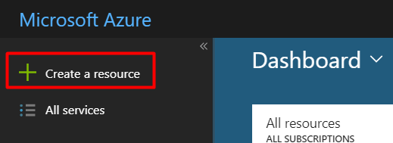

1.After you are logged in you can see left on your dashboard an option to make a new rescource, click on this.

2. Search ‘Logic apps custom connector’ and click on the result. After that click on ‘create’.

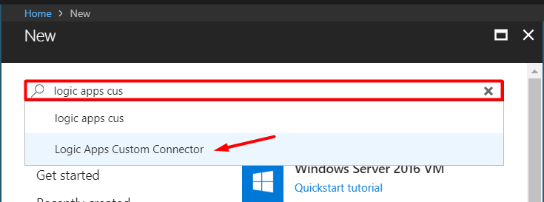

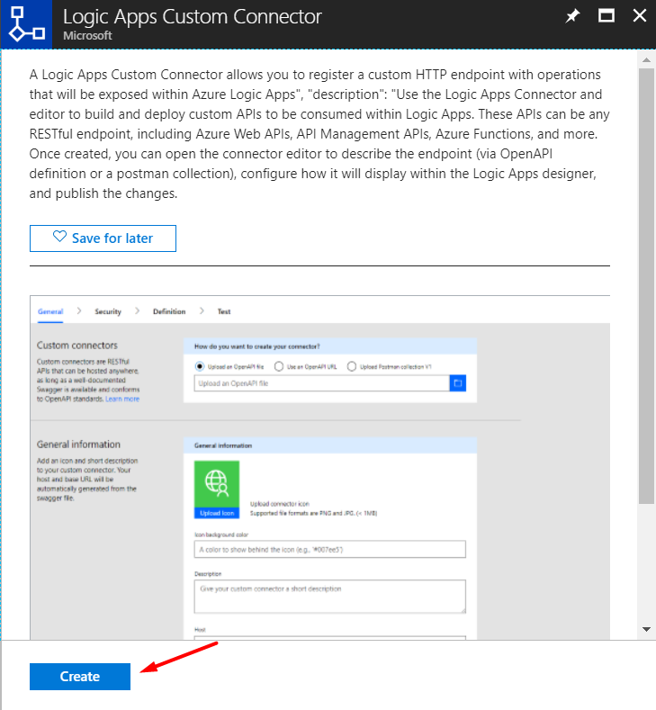

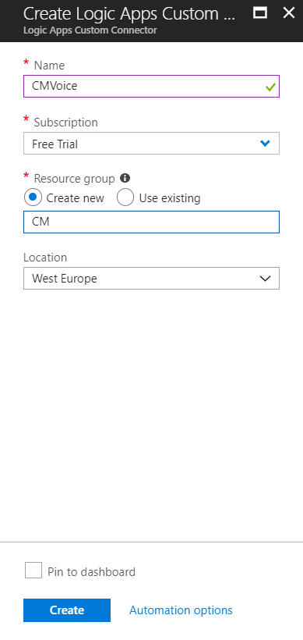3. Choose a name for your connector. After that select a type of subscription. Then choose a rescourcegroup and a location for your connector. Click on ‘create’.

# Step 2: Configuring the logic app

https://cdn.discordapp.com/attachments/359058606429175828/451678789131436050/unknown.png4. You will be sent back to the dashboard. After a while you will get a notification. Click on it.

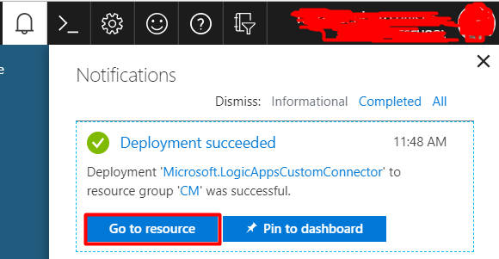5. You will see this message click on ‘Go to rescource’.

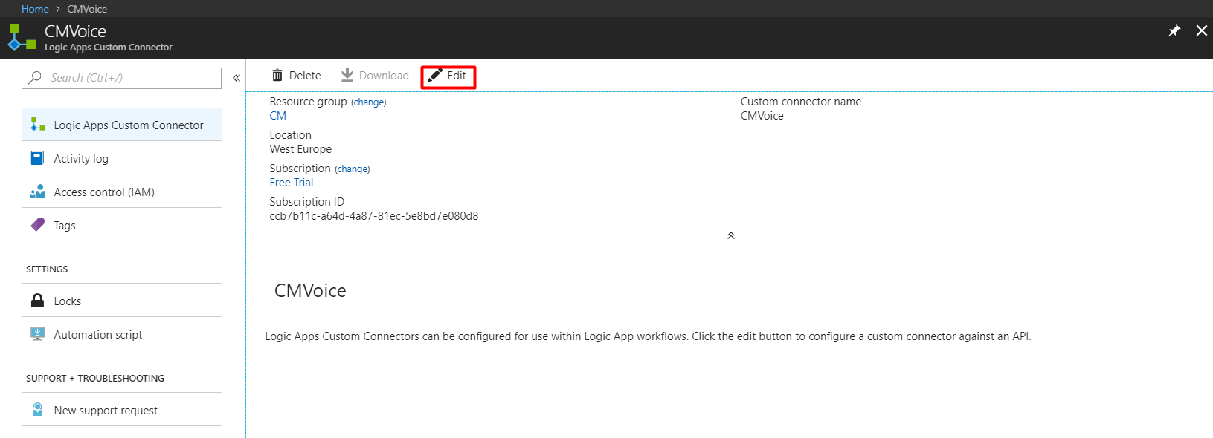6. You will see this window click on ‘Edit’.

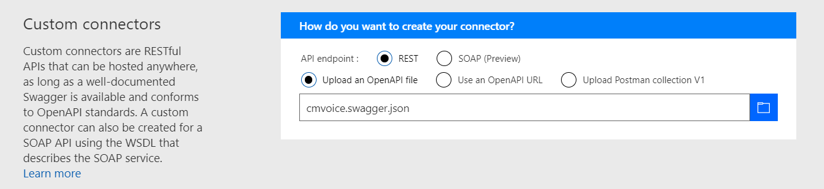7. You can ignore Custom connectors. Scroll down and go to General Information.

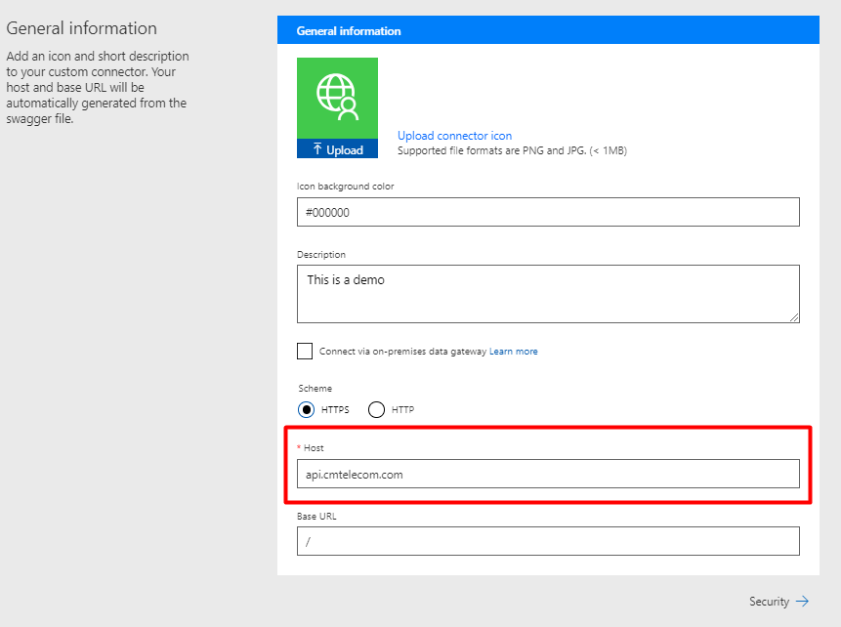8. You can add a background color and description to your liking. Leave scheme as HTTPS. But make sure you set the host field to: **api.cmtelecom.com.** Click on security when you’re done to go to the next step.

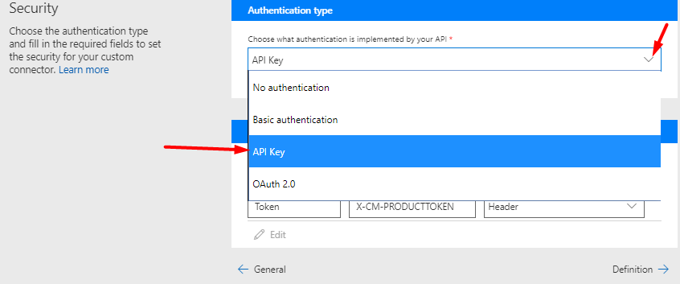

9. From the first dropdown select API Key.

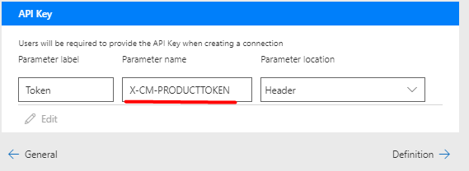10. Fill in the blanks as followed make sure you spell the parameter name correctly. When you’re done click on Definition.

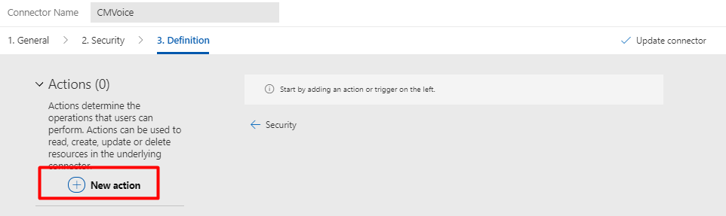

11. To add a new action click on the plus sign.

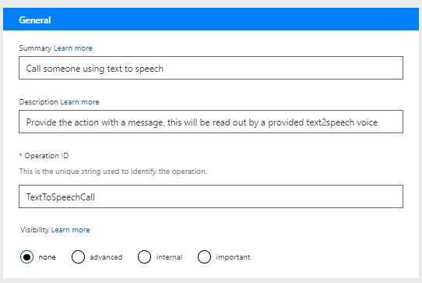

12. A form will appear, enter a summary, description a and a unique name identifier. Scroll down for the next step.

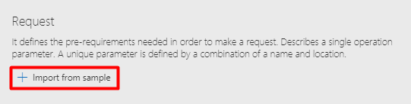

13. Under the tab general is a link with the title request. Click on it.

14. On the right side a form will appear, select POST and enter the fields as followed separated by new line. When you’re done click ‘import’.

**URL:**

https://api.cmtelecom.com/voiceapi/v2/Notification

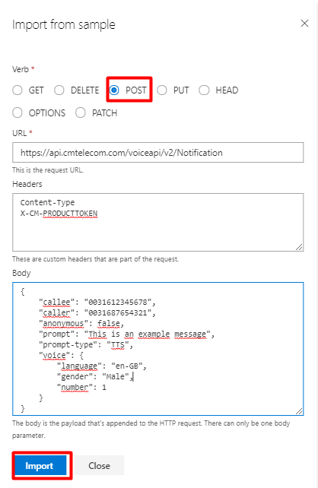**Headers:**

Content-Type

X-CM-PRODUCTTOKEN

**Body:**

{

"callee": "0031612345678",

"caller": "0031687654321",

"anonymous": false,

"prompt": "This is an example message",

"prompt-type": "TTS",

"voice": {

"language": "en-GB",

"gender": "Male",

"number": 1

}

}

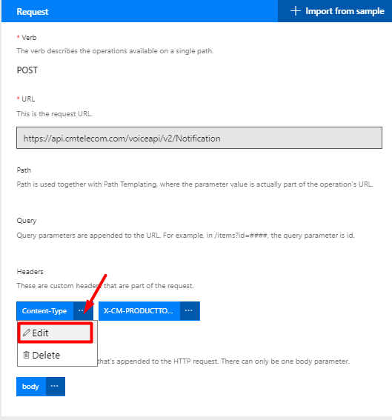

15. After you pressed ‘import’ you will see a form like this. Click on Content-Type and click on ‘Edit’.

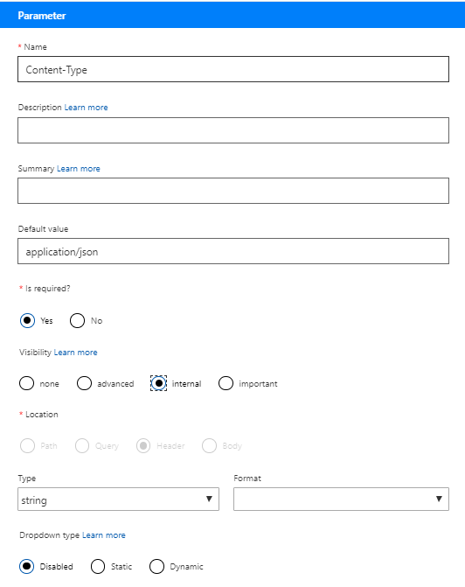16. After you clicked on ‘Edit’ you will see this form fill it in as follows:

**default data:**

application/json

**required:**

yes

**Visibility:**

Internal

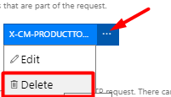

17. You can remove the token.

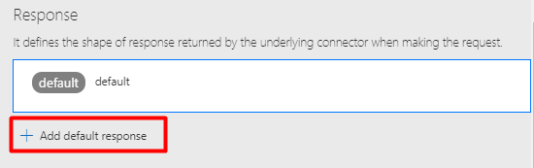

18. Scroll down and add a default response

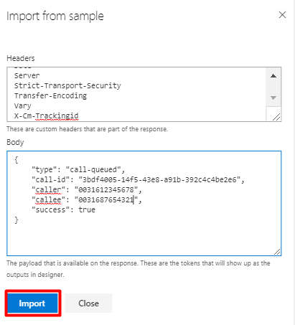19. Fill in the form as follows click on ‘import’ when you’re done.

**Headers:**

Access-Control-Allow-Credentials

Access-Control-Allow-Origin

Connection

Content-Encoding

Content-Type

Date

Server

Strict-Transport-Security

Transfer-Encoding

Vary

X-Cm-Trackingid

**Body:**

{

"type": "call-queued",

"call-id": "3bdf4005-14f5-43e8-a91b-392c4c4be2e6",

"caller": "0031612345678",

"callee": "0031687654321",

"success": true

}

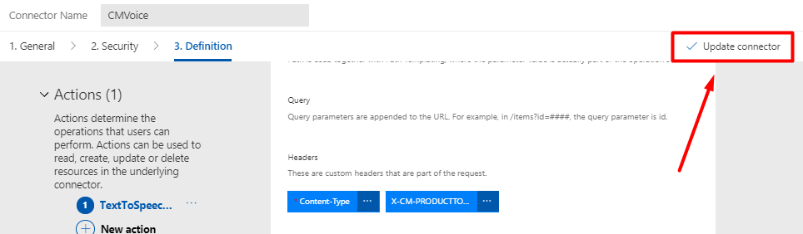20. When you’re done with making a response click on ‘update connector’.

Congratulations! You are now the proud owner of your own custom Voice Connector. ☺